Airline Passenger Demand Forecasting using ARIMA

1. Introduction

Airline companies rely heavily on accurate passenger demand forecasting to optimize aircraft utilization, workforce scheduling, fuel planning, and route management. Poor demand estimation can lead to underutilized flights, increased operational costs, and revenue losses.

Passenger demand data often exhibits a long-term upward trend and seasonal variations, making it non-stationary in nature. Traditional forecasting techniques fail to produce reliable results when applied directly to such data.

This project focuses on implementing an ARIMA (AutoRegressive Integrated Moving Average) model to forecast monthly airline passenger demand by transforming non-stationary data into a stationary form and generating accurate future predictions.

2. Problem Statement

An airline company seeks to forecast monthly passenger demand to optimize aircraft allocation, workforce planning, and route scheduling. Historical passenger data demonstrates a long-term growth trend, making the series non-stationary. Forecasting models built without addressing this non-stationarity produce unreliable predictions and inaccurate demand estimates, negatively impacting operational efficiency and revenue planning.

3. Objectives

To analyze historical airline passenger data

To identify non-stationarity in time series data

To apply differencing techniques to make the data stationary

To build and train an ARIMA model

To evaluate forecasting accuracy using statistical metrics

To generate future passenger demand forecasts

4. System Requirements

Hardware Requirements

Standard computer with minimum 4GB RAM

Software Requirements

Python

Pandas

NumPy

Statsmodels

Matplotlib

5. Dataset Description

The dataset contains monthly airline passenger counts recorded over several years.

Attributes:

Month (Date)

Passengers (Number of passengers)

The dataset shows:

Increasing trend over time

Seasonal patterns

Non-stationary behavior

6. Methodology

6.1 Workflow

Data Collection → Data Preprocessing → Stationarity Check → Model Training → Evaluation → Forecasting

6.2 Data Preprocessing

Converted date column into datetime format

Set date as index

Visualized the time series to identify trends and patterns

📌 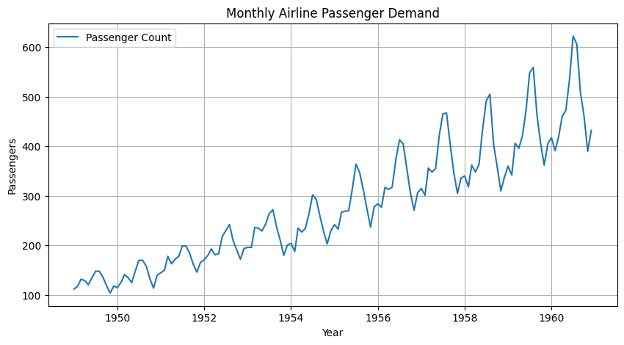

6.3 Stationarity Check

The Augmented Dickey-Fuller (ADF) Test was used to check stationarity.

Null Hypothesis (H₀): Series is non-stationary

If p-value > 0.05 → Non-stationary

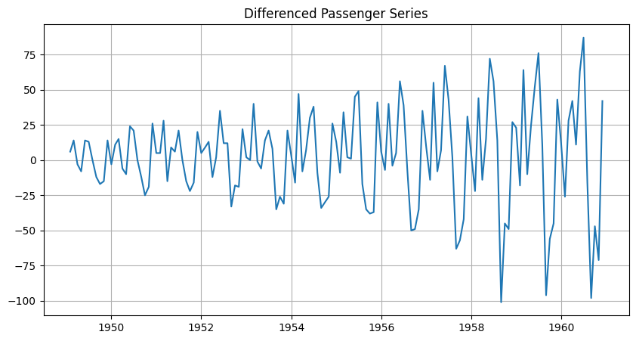Result:
The original series was non-stationary, confirming the need for differencing.

6.4 Differencing

First-order differencing was applied to remove the trend and stabilize the mean.

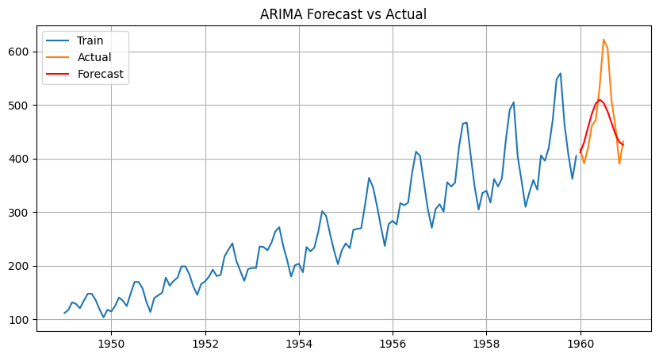After differencing:

Mean became stable

ADF test confirmed stationarity

6.5 ARIMA Parameter Selection

ARIMA parameters:

p → Autoregressive order

d → Degree of differencing

q → Moving average order

ACF and PACF plots were used to identify suitable values.

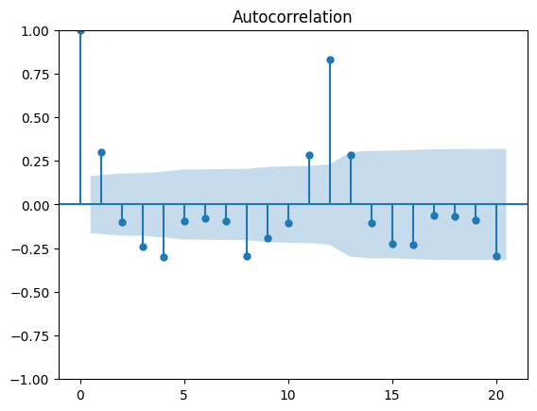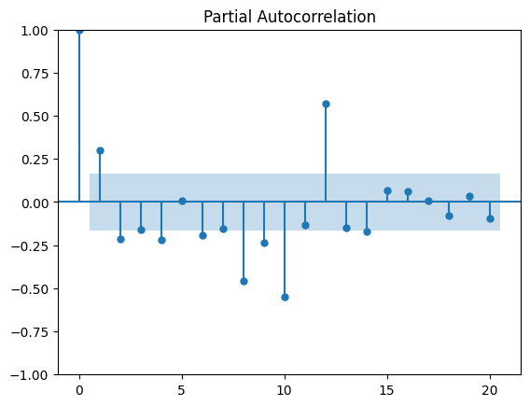Selected parameters:

p = 2

d = 1

q = 2

6.6 Model Training

The dataset was split into training and testing sets.
The ARIMA model was trained using the training data.

6.7 Model Evaluation

The performance of the model was evaluated using:

Mean Absolute Error (MAE)

Root Mean Squared Error (RMSE)

These metrics confirmed that the ARIMA model produced reliable and accurate predictions.

6.8 Future Forecasting

The trained ARIMA model was used to forecast passenger demand for future months.

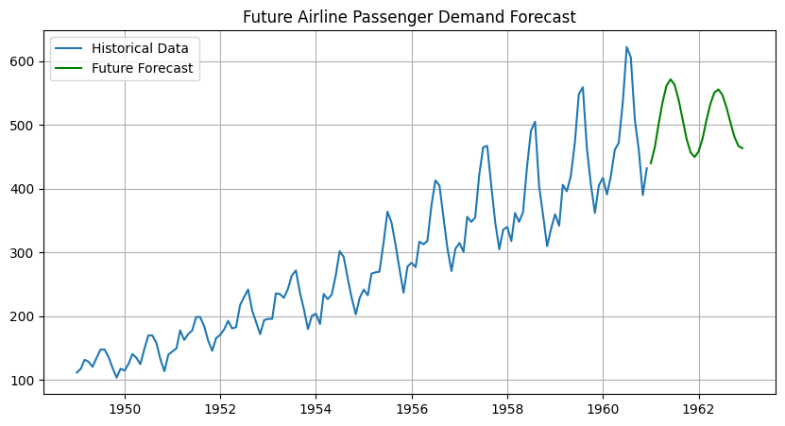This forecast helps airline companies plan resources and operations effectively.

7. Results and Discussion

The ARIMA model successfully handled non-stationary time series data

Differencing played a key role in improving prediction accuracy

Forecasted values closely followed actual passenger trends

The model demonstrated practical applicability in airline demand planning

8. Conclusion

This project demonstrated the effectiveness of ARIMA models in forecasting airline passenger demand using non-stationary time series data. By applying appropriate differencing techniques and parameter selection, reliable predictions were achieved. The approach can be extended to include seasonal components using SARIMA for even better accuracy.

9. Future Enhancements

Implement SARIMA to capture seasonality

Compare ARIMA with LSTM and Prophet models

Integrate real-time airline booking data

Deploy forecasting model as a web application

10. References

Box, G. E. P., Jenkins, G. M., & Reinsel, G. C. – Time Series Analysis

Statsmodels Documentation

Airline Passenger Dataset

